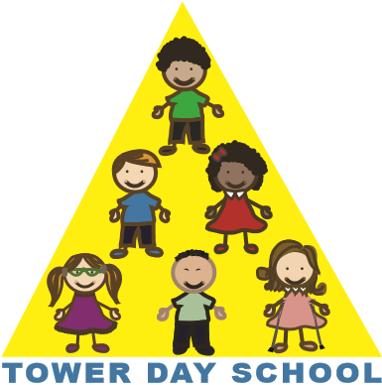

Tower Day School

Application Form

2024/2025

Child’s Name: ______________________________________________________________________________

Date of Birth: _______/______/_____________ Sex: M_____________F____________

Parent’s Name: _____________________________________________________________________________

Home Address: _____________________________________________________________________________
Street Town Zip

Phone: _________________________________email: ______________________________________________

Name(s) of sibling(s) who have previously attended Tower Day School:

__________________________________________________________________________________________

Please number your class choices in order of preference.

2.9 year-old class (start date January 2025)

___ T-TH class (8:30 - 11:30)

3 year-old class options

___ T,TH class (8:30 - 11:30)

___ M,W,F class (8:30 - 11:30)

___ M-F class (8:30 – 11:30)

4 year-old class options

___ M,W,F class (8:30 - 11:30)

___ M-F class (8:30 – 11:30)

___ M,W,F FULL DAY class (8:30 - 2:30)

___ T,W,TH FULL DAY class (8:30 - 2:30)

Transition class

___ M,W,F (8:30 - 11:30) and T,TH (8:30 - 2:30)

___ Yes, I have read the attached Application Information.

Signature___________________________________________________Date____________________________

Please return this form along with your $75.00 application fee (one per family)
The application fee is refundable if we cannot offer you one of your class choices.
Make checks payable to: Tower Day School

5 Summer Street, Lynnfield, MA 01940 towerdayschool@gmail.com 781.334.5576 www.towerdayschool.org

